HILLY FIELDS FOOTBALL CLUB
SEASON 30: 1996-97
Beckenham Hospital Veterans Cup
P W D L F A
2 1 0 1 11 6
Lewisham Hospital Veterans Cup
2 1 0 1 8 7
Friendly 14 5 1 8 38 46
TOTAL 18 7 1 10 57 59
Apps Gls Apps Gls
Bill Baker 1 1 Shaun Litchfield 1 0
Irving Bartlett 2 2 John Madden 3 0
Jeff Bellairs 1 0 Kevin Marchant 7 0
Mark Cooper 6 0 Ray Marchant 6 1
Terry Dyke 14 0 Steve Morton 12 5
Keith Farquahar 11 5 Richard Patterson 14 11
Barry Fitzsimmons 7 3 Paul Quinn 14 0
Steve Ford 1 1 Steve Quinn 13 2
Keith Foster 12 1 Tommy Salacuri 1 1
Ian Graver 0 0 Micky Spicknell 12 3
Eddie Hicken 9 0 Albert St Clair 5 2
Richard Hulbert 1 0 Dick Stone 9 0
Howard Jones 7 3 Mario Vaz 6 0
Mark Jowitt 1 0 Dave Wright 2 0
Mike Jefferys 1 0 Chris Yusuf 12 6
Mark Kellaway 2 4 OG 1
John Kennedy 2 1
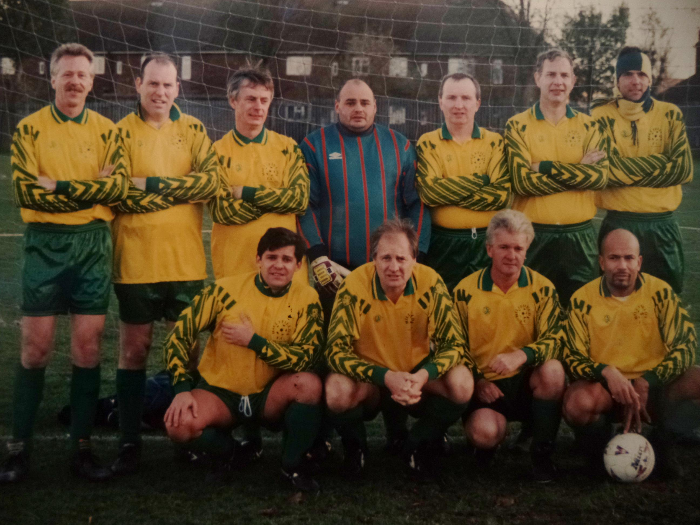
L-R Back: Mark Cooper, Barry Fitzsimmons, Dick Stone, Eddie Hicken, Paul Quinn, Keith Foster, Howard Jones
L-R Front: Keith Farquahar, Richard Patterson, Steve Quinn, Chris Yusuf

